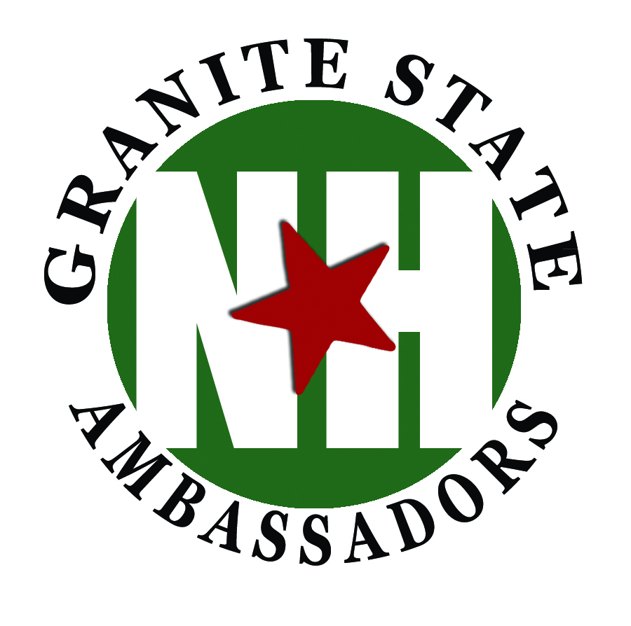
Granite State Ambassadors
Annual Yearbook Advertising Commitment

Print Date: June 2019
Distribution: 500 to GSA volunteers and industry partners

Contact Person:
Email:
Phone:
Company Name:
Billing Address:

Indicate Size | Description | Advertisement Size | Member / non-Member price
 | Full Page | 8” x 10.5” | $500 / $525
 | Half Page Horizontal | 8” x 5” | $300 / $325
 | Half Page Vertical | 3.75” x 10.5” | $300 / $325
 | Quarter Page | 3.75” x 5” | $150 / $175

[ ] Member Rate

- Advertisements must contain “well wishing” sentiment - thanking or supporting Granite State Ambassador volunteers.
- Advertisements are full color and must be submitted camera ready - minimum of 300 dpi.
- Advertisements will have a quarter inch margin (not full bleed).
- Advertisement copy due May 22, 2019

Total Amount: $__________________
Make checks payable to: NHGSA
[ ] Payment enclosed [ ] Invoice me
[ ] Email me a PayPal invoice so I can pay by PayPal or credit card.

Signature: _____________________________________ Date: _________________________

NH Granite State Ambassadors • 470 Mast Road, Goffstown, NH 03045
www.nhgsa.com • Kelly@nhgsa.com • 603-960-0272
NH nonprofit 501(c)3 – your donations are tax deductible

