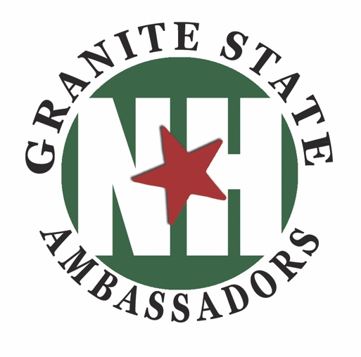
January 3, 2020

For immediate Release
Granite State Ambassadors
Kelly Bryer, Executive Director
603-960-0272 kelly@nhgsa.com

Photo: https://goo.gl/photos/RsrGGpLMcnopsA3VA

NEW HAMPSHIRE GRANITE STATE AMBASSADORS ANNOUNCES
GSA CERTIFICATION TRAINING FOR 2020

New Hampshire Granite State Ambassadors (NHGSA) seeks enthusiastic people who enjoy sharing their passion for our beautiful state with others, want to learn more about our state, make new friends, and have a few hours each month to volunteer as a Granite State Ambassador (GSA). Volunteer opportunities are at over 40 statewide Visitor and Information Centers & special events. Industry personnel, such as those working in local chambers, hotels, restaurants, real estate offices, libraries, schools, and more are also encouraged to participate in the training to enhance their current roles.

The goal of the GSA certification training is to reinforce the tools and knowledge needed to meet and exceed the expectations of guests and support the authentic culture of New Hampshire, its people, and its products. The 2-day training includes 14 comprehensive hours of learning through lectures and sharing. Over the course of the 2 days, attendees will hear from over 20 speakers on subjects including tourism, hospitality, outdoor recreation, attraction and heritage tourism, business, economic development, industry, and education. Attendees come to understand why “it’s always sunny in New Hampshire.”

This year’s GSA certification training sponsors and locations are: March 9-10, 9am-4pm Manchester Millyard Museum, Manchester; April 13-14, 9am-4pm Kimball Jenkins, Concord; Hampton Area Chamber of Commerce / Hampton Beach State Park at the Seashell Pavilion, Hampton; and August 3-4, 9am-4pm at the Franklin Savings Bank Community Learning Center, Tilton.
The certification fee is $50.00 per person and includes training, materials, lunch and snacks during training days, tour of host location, prizes and surprises, graduate certificate, official NHGSA name tag, and volunteer membership to NHGSA. For more information and to register please visit NHGSA online at www.NHGraniteStateAmbassadors.org

Certified GSAs have numerous opportunities each year to reinforce certification and update skills by participating in free activities, tours, special events, and specialized trainings. It’s fun and a great way to meet others who live here or are visiting and want to know more. Being a GSA is for anyone 18-80 who loves talking to visitors about the Granite State. Children under 18 can volunteer with a parent or grandparent who is a certified GSA, through our Future Leaders of New Hampshire Program.

About New Hampshire Granite State Ambassadors
New Hampshire Granite State Ambassadors (NHGSA) add value to state agencies, local businesses, and individuals through a training and service support network that sustains and enhances the New Hampshire experience. As a 501(c)(3) non-profit, charitable organization, NHGSA serves hundreds of travel and tourism related businesses including key partners, Manchester-Boston Regional Airport and the NH Division of Travel and Tourism Development. Our award-winning organization has certified 1,800 residents and employees who staff front-line visitor centers that support the authentic culture of New Hampshire, its people, and its products. Since 1996, GSAs have given over 340,000 hours of volunteer service providing personal assistance to millions of guests visiting the Granite State. Our GSAs actively serve New Hampshire city, state, federal, and private organizations, such as regional associations, chambers of commerce, and major events. Find out more about NHGSA, Inc. at www.NHGraniteStateAmbassadors.org

# # #

Granite State Ambassadors
470 Mast Road, Goffstown NH 03045
Voicemail: 240-621-0638 info@nhgsa.com
www.NHGraniteStateAmbassadors.org | www.NHGSA.com

