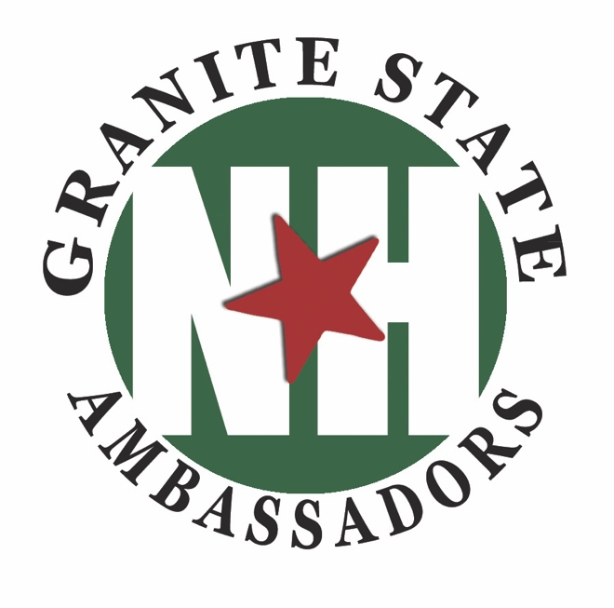
New Hampshire Primary
Rules of the Road

During the weeks leading up to the New Hampshire Primary you will encounter many celebrity members of the press and candidates. You will also be assisting their entourage, affiliates, primary vacationers…

When in Granite State Ambassador uniform, you are not you. You are representing Granite State Ambassadors; the organization that owns the center or event; and the State of New Hampshire.

Remember your role while on duty – you are a professional information specialist and there to do a job, which is to be helpful, answer their questions and make sure their experience and impression of New Hampshire is a positive one.

They are just people with a job to do. It can be tempting to engage with them as a super-fan or with disdain. Your personal opinions and issues cannot be brought into play directly or indirectly while on duty.

Do not chase anyone for autographs or photos. If they are at the visitor center, engaging with you directly, you can ask, but that is where it has to end. If you are volunteering at the hotel, you cannot ask for photos or autographs. We have to follow the same policies their staff does.

You are never ‘off the record.’ If your polite conversation starts to feel like an interview or if the questions are getting direct – stop. Explain to them that you are a volunteer and are not authorized to give interviews. Give them the business card of the organization’s Director. Remember there are always larger issues and initiatives at play which is why organizations have a designated spokesperson. A seemingly innocent conversation may jeopardize a project of the organization we contract with if the messaging doesn’t align.

There is a time and place for soap-boxes and political questions. While on duty you need to stay professional. You can, however, ask when the next rally or forum is so you can attend to express your opinions.

