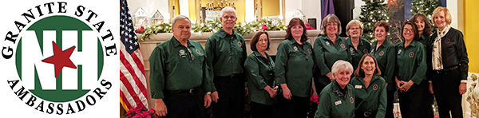

CELEBRATING OUR 25th ANNIVERSARY IN 2021
Help us to continue our mission to support you for another 25 years!
Granite State Ambassadors is a 501(c)3 charitable nonprofit organization, and we rely on your
donations and support to keep you in front of our volunteers and NH's guests.
Please donate to our December 2020 Fundraising Raffle - email to: kelly@nhgsa.com
or mail gift certificates to: Kelly Bryer (home office), NHGSA, PO Box 417, Campton NH 03223
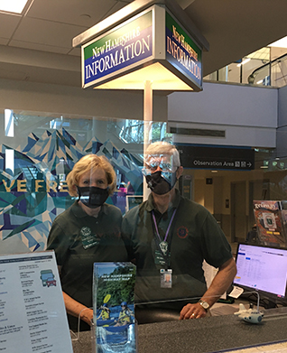
- Be interviewed by our staff so our GSAs can learn more
- Teach a virtual educational program for our GSAs - lecture, tour... We want to learn about what you do and what makes you special
- Share your developed virtual learning experiences and articles with us
- Email us your news and events to include in our newsletter
- Participate in our year-long 25th Anniversary celebration
- Apply to be on our Board of Directors
Our Granite State Ambassador volunteers are currently out welcoming guests and referring you at the Manchester-Boston Regional Airport, Manchester Millyard Museum, Bedrock Gardens, Greater Concord Chamber of Commerce, Lake Sunapee Region Chamber of Commerce, Kimball Jenkins Estate, Chamber Collaborative of Greater Portsmouth, Hooksett, Canterbury, Salem and Seabrook State Welcome Centers. We are excited to add more locations as things open back up.
Even during the pandemic, 266 of our 350 of our active GSA volunteers have served 7,372 hours from Jan-Sept 2020, giving guest referrals, participating in learning activities and promoting you!

Business Name: ____________________________________________________________________________
Mailing Address: ___________________________________________________________________________
Contact Name: __________________________________ Email: ____________________________________
Website: _________________________________________________________________________________
Donation:________________________________________________________________________________
Expiration / Restrictions: ___________________________________________________________________
Value: ___________________________ Please mail certificates to: NHGSA PO Box 417, Campton NH 03223
Kelly Bryer, Executive Director | Granite State Ambassadors | 603-960-0272 cell | kelly@nhgsa.com

